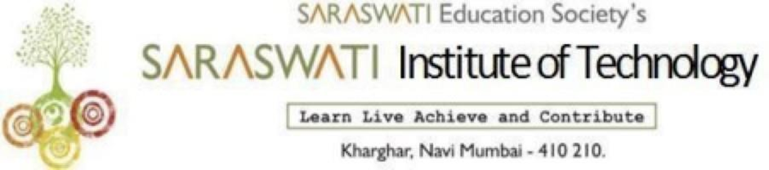
DEPARTMENT OF INFORMATION TECHNOLOGY
Date:-24/12/2025
Report on Expert Lecture

Title :- Personality Development Lecture of Art Of Mind Control
Date :- 23/12/2025
Time :- 10:00 to 11.30
Venue: Saraswati Institute of Technology
Subject Expert: Mr. HG Rupanuga Das
Participants :- FY, SY, TY IF Students
The Department of Information Technology with the help of IFSA organized a Personality Development lecture conducted by Mr. HG Rupanuga Das on 23/12/2025 from 10.00 to 11.30 am for First, Second and Third Year students on the topic "Art Of Mind Control". The lecture introduced the concepts of Mind control, limiting garbage content in and out of our mind, and the psychology behind social media influencing our minds.
The topic covered was appreciated by most of the students and requested to arrange such kinds of lectures in the future too. We are thankful to Mr. HG Rupanuga Das for spending his valuable time with us and sharing knowledge.
A total of 150 students, and 10 faculty members benefited from this lecture.

IFSA Coordinator H.O.D Principal
Mr. Raj Sinha Mrs.Jyoti Shinde Dr. D.R.Suroshe

DEPARTMENT OF INFORMATION TECHNOLOGY
Photos from the Lecture
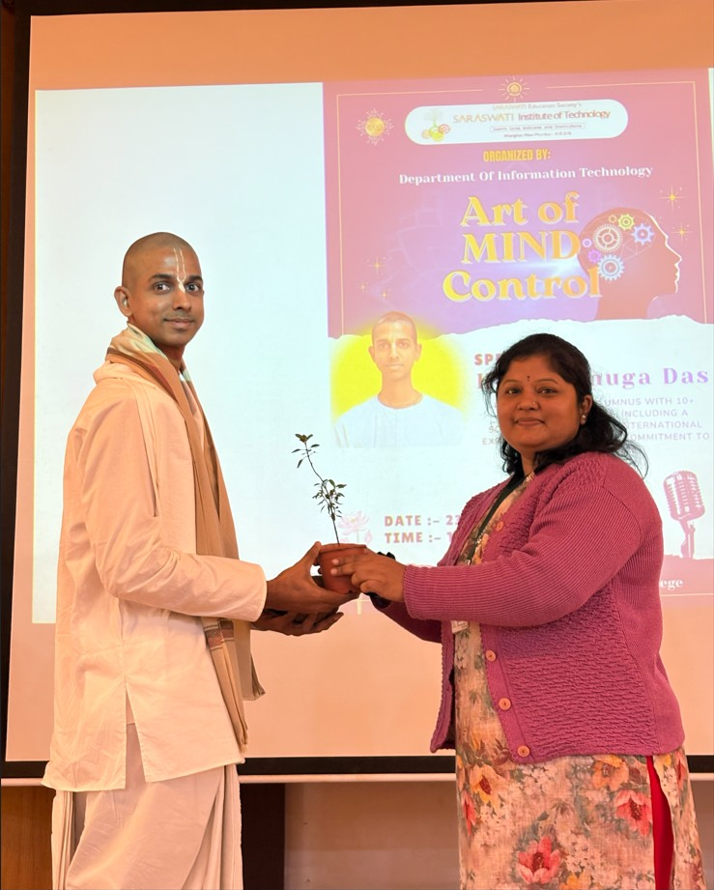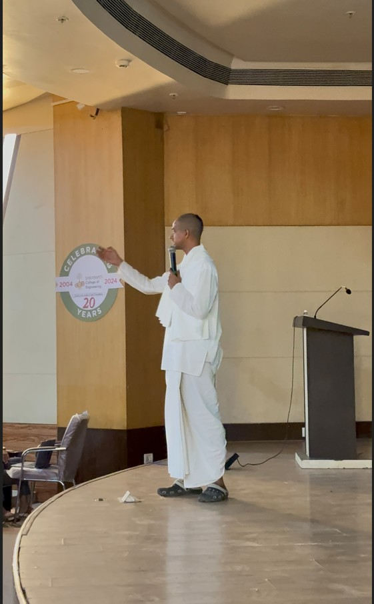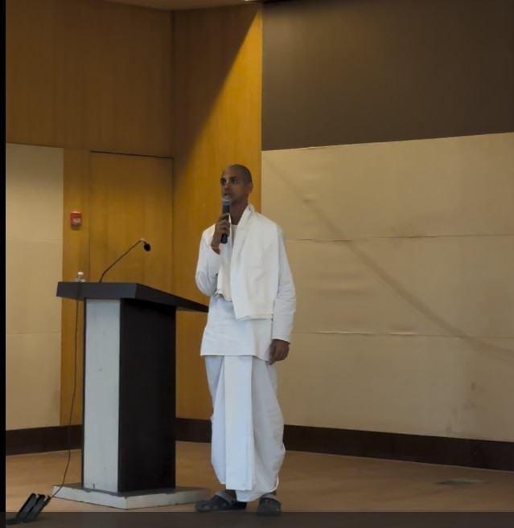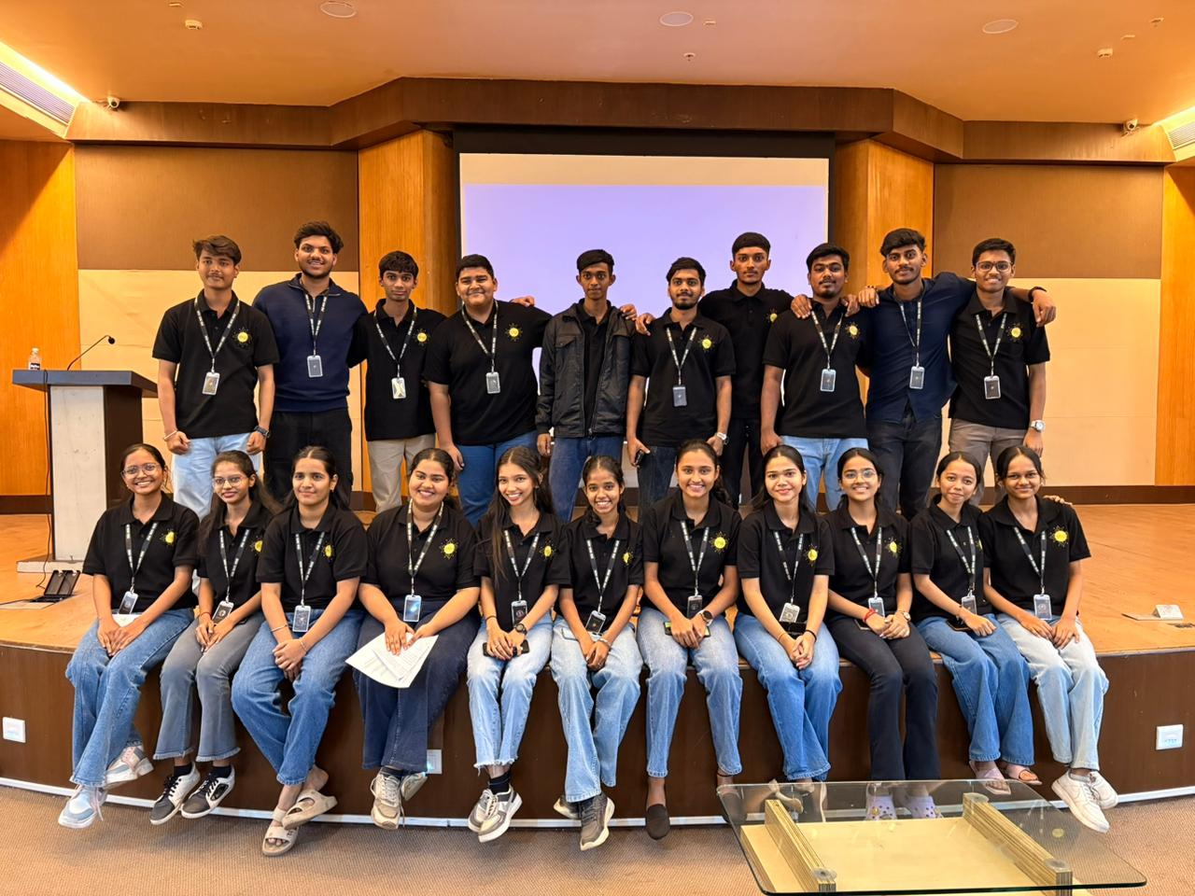

Technical Coordinator H.O.D Principal
Ms.Mayuri Kushwaha Mrs.Jyoti Shinde Dr. D.R.Suroshe

